**Instructions to run the code:**

1. At first , install Code::Blocks.
2. The XAMPP is to be installed closing the antivirus. The installation file is provided.
3. The provided “data” folder is to be copied and replace with the existing “data” folder in the following directory:

“C:\xampp\mysql”

(The above directory is if XAMPP is installed in C drive. Otherwise, type the directory in place of ‘C:’ where XAMPP is installed)

1. Open the XAMPP Control Panel and start ‘Apache’ and ‘MySQL’.
2. If ‘Apache’ or ‘MySQL’ fails to start, then the port number is engaged and the port number should be changed.
3. Otherwise, it is not necessary to change the port number.
4. After starting ‘Apache’ and ‘MySQL’, open any browser like Google Chrome.
5. Type ‘localhost’ in the URL to see the database.
6. Click on ‘phpMyAdmin’ on the top right options.

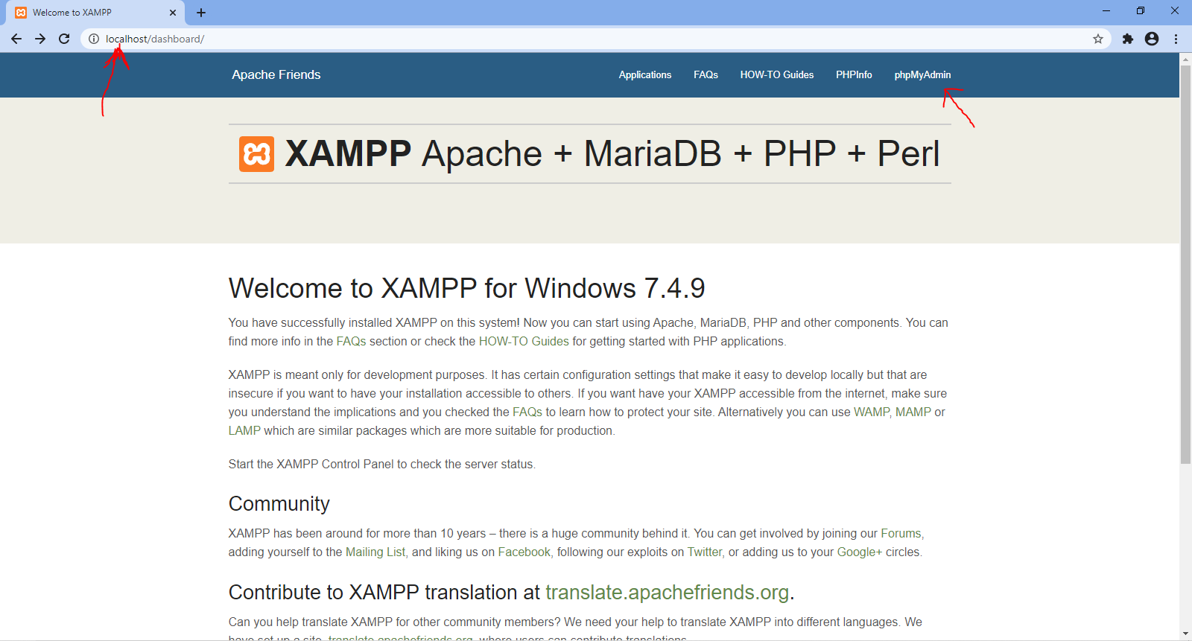

1. 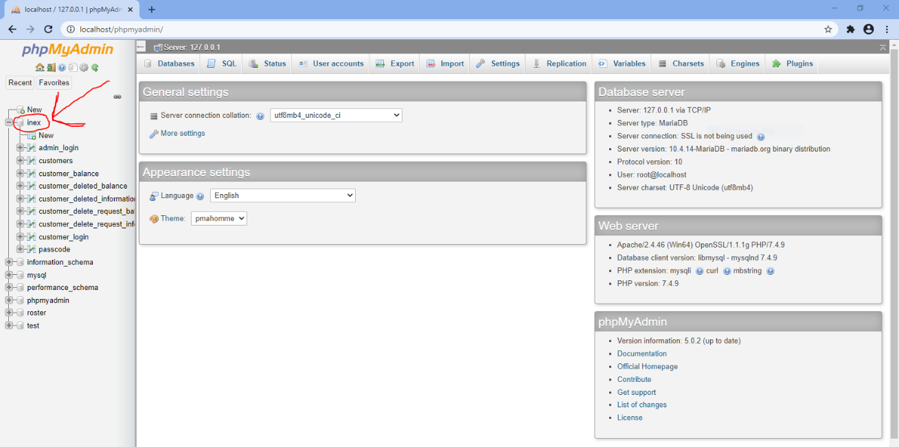Click on ‘inex’ from the list of databases on the left.
2. All the information can be accessed from here.
3. Later on, extract the ‘MinGW.zip’ file and replace with the existing ‘MinGW’ folder of the Code::Blocks.

(Replacement is important because this ‘MinGW’ folder contains some necessary files to run the code.)

1. Open the provided ‘inex [source code]’ folder and open the ‘inex.cbp’ file with Code::Blocks.
2. Open the ‘main.cpp’.
3. Click on ‘Project’ from the top left options and open the ‘Build options…’.

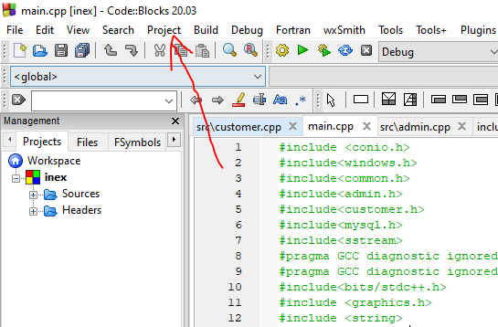

1. Click on ‘Debug’ on the left.

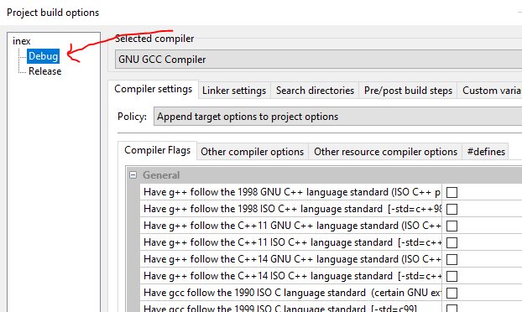

1. Click on ‘Linker settings’ and select ‘Clear’ and ‘OK’.
2. Then, click on ‘Add’. Browse to your CodeBlocks folder and then MinGW, mingw64, lib and open ‘libmysql.a’ file.

CodeBlocks > MinGW > mingw64 > lib > libmysql.a

1. On the new prompt, click on ‘Yes’ to add this as relative path. In my case, the directory is :- “E:\Nahian\CodeBlocks\MinGW\mingw64\lib\libmysql.a”.

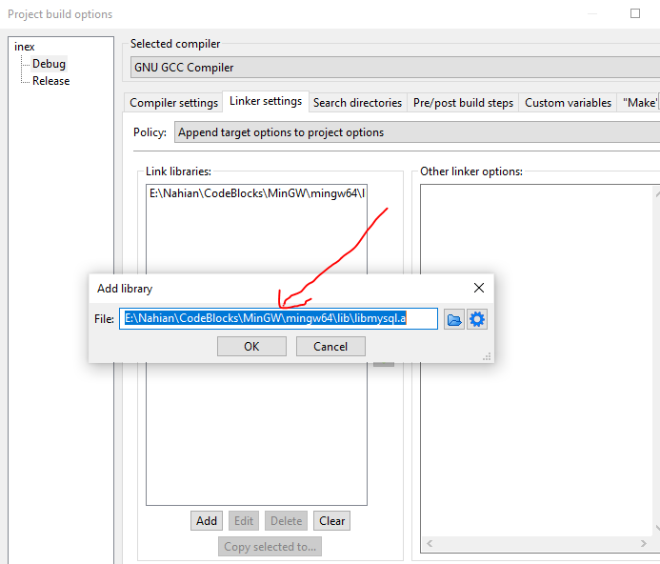

1. Click on ‘OK’.
2. Next, click on ‘Search Directories’ and check if it contains ‘include’ or not. If ‘include’ is not present, click ‘Clear’ and ‘OK’ and add ‘include’.

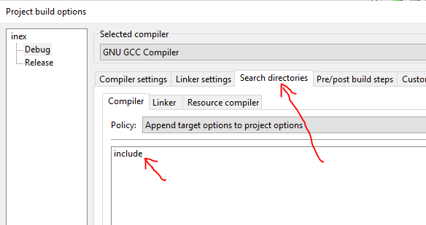

1. Click on ‘OK’ to exit from the ‘Build options…’.

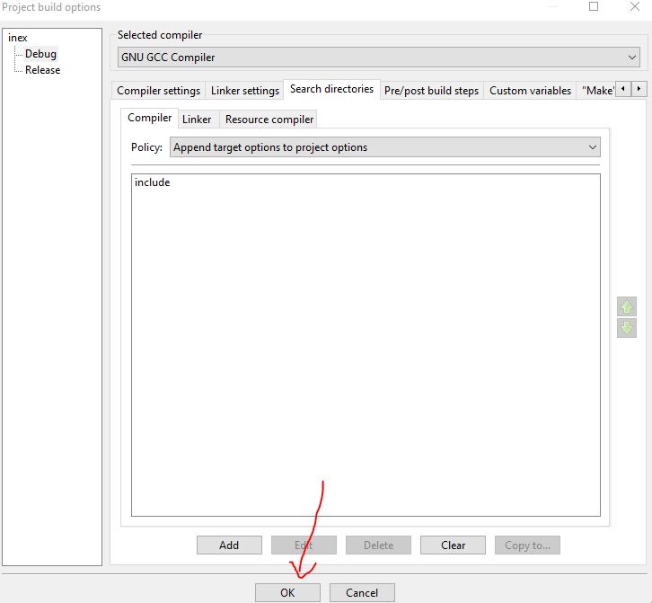

1. Now, click on ‘Settings’ from the top options and open ‘Compiler…’.

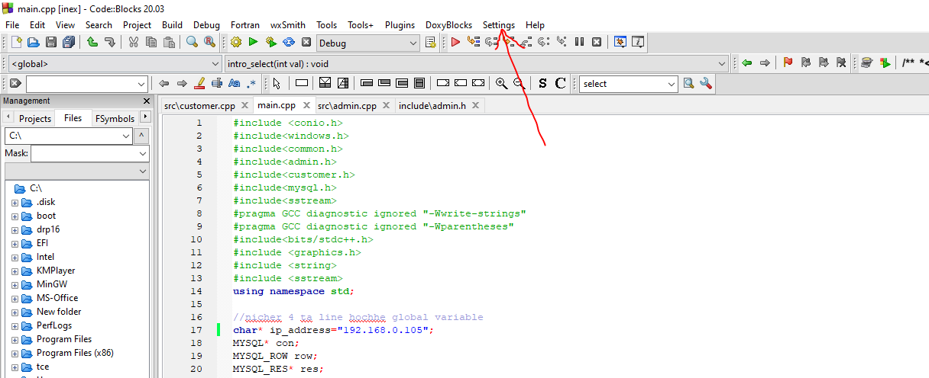

1. Click on ‘Linker settings’ and select ‘Clear’ and ‘OK’.
2. Then, click on ‘Add’. Browse to your CodeBlocks folder again and then MinGW, lib and open ‘libbgi.a’ file.

CodeBlocks > MinGW > lib > libbgi.a

1. In my case, the directory is :-

E:\Nahian\CodeBlocks\MinGW\lib\libbgi.a

1. Click on ‘OK’.
2. Now, on the right part ‘Other linker options:’, copy and paste this :-

-lbgi

-lgdi32

-lcomdlg32

-luuid

-loleaut32

-lole32

(If it is already present, no need to copy and paste.)

1. In my case:-

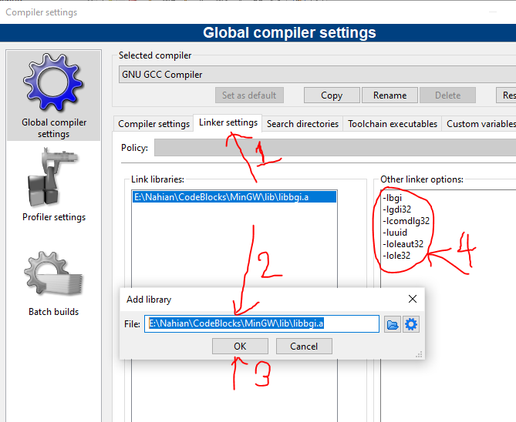

1. Click on ‘OK’ to exit from the settings.

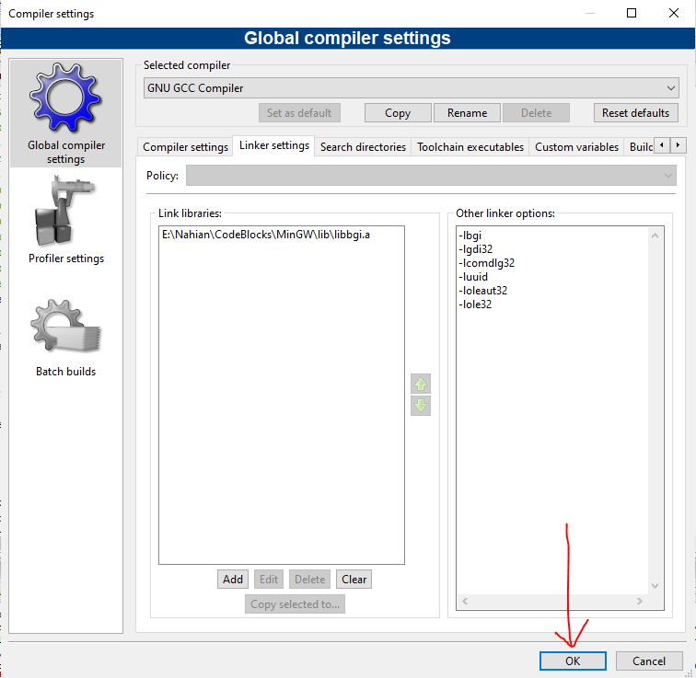

1. Open the Command Prompt(cmd) and type ‘ipconfig’ and press ‘enter’.

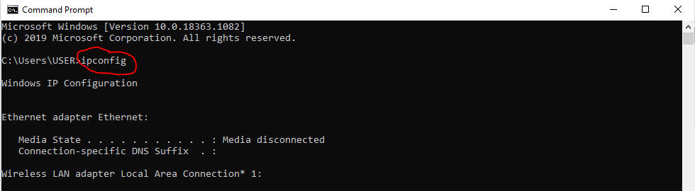

1. Scroll down and copy the ‘IPv4 Address’. (In my case, it is 192.168.0.105)

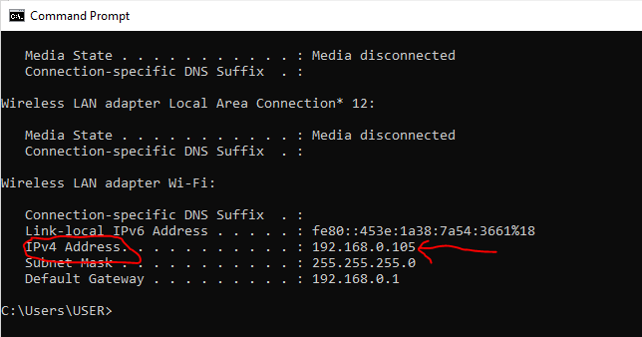

1. After copying the IPv4 Address, replace with the Address in line no. 17 of the main.cpp file. This address changes frequently with the change of the internet connection.

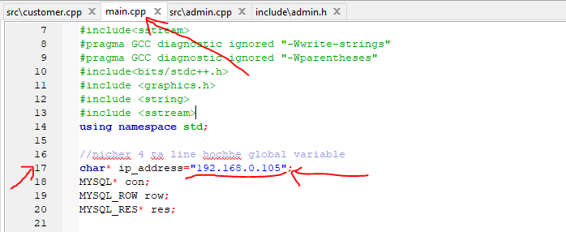

1. 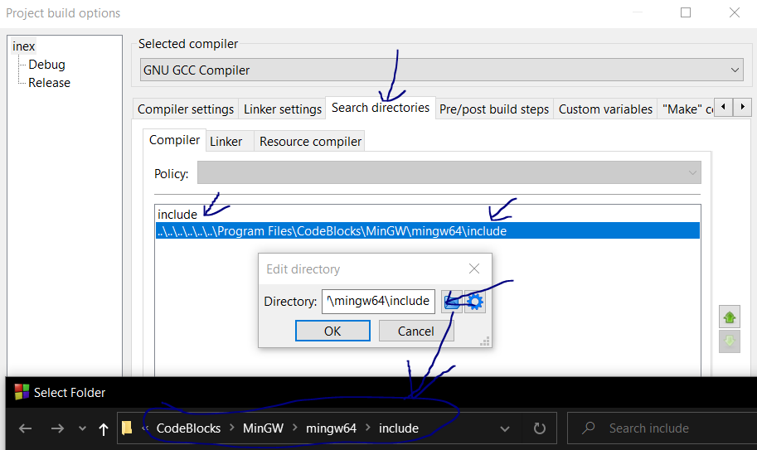If there is any error while running like “mysql.h; no such file or directory”, then go to instruction no. 21. Along with “include” add the directory of any folder which has “mysql.h” file.

For example:

1. Everything is done !!
2. If the compiler is not detected, use ‘Auto-detect’ to detect the compiler.
3. Build and Run the code.
   1. If ‘Connected !!’ is shown in the console, everything is OK.
   2. If ‘Not Connected !!’ is shown in the console, follow instruction no. 3 and 30, 31, 32 again.
4. Enjoy the project !!

[ Developed by our group ‘*INEX*’ having group leader *Nahian Ibn Asad* along with *Md. Mushfiqul Haque Omi* and *Shaidur Rahman Nizami* ]